AI Mini Project: Multi-Agent System Design

Project Theme: "The Entity" - Cyber-Defense Multi-Agent Countermeasure Unit
Group: No. 2

1. Team Leader: Haziqah Binti Halim

2. Team Leader & Workload Allocation
Member | Responsibilities
HAZIQAH BINIT HALIM  (Leader) | - Manage GitHub repository  - Create LLM API (.env setup)  - Create Gantt chart  - Set up core environment (main.py, Gemini LLM initialization)  - Write code for Agent 3 - Analyzer + custom tool  - Build dynamic router + workflow (2 conditional routing paths)  - Submit final zip file to VLE
MUHAMMAD AQIL AQMAR BIN GHULAM ZAEDI | - Build Agent 1 - Decoy + 1 custom tool  - Prepare few-shot input/output examples and prompt refinement log for report  - Generate requirements.txt
MARDINA BINTI SHAHARUDIN | - Build Agent 2 - Infiltrator + 1 custom tool  - Implement error handling (3 distinct try-except blocks)  - Test the 5-second fallback mechanism  - Merge all code  - Final check of code and report

3. Project Timeline (Gantt Chart)

Project duration: 1 August 2026 - 11 September 2026
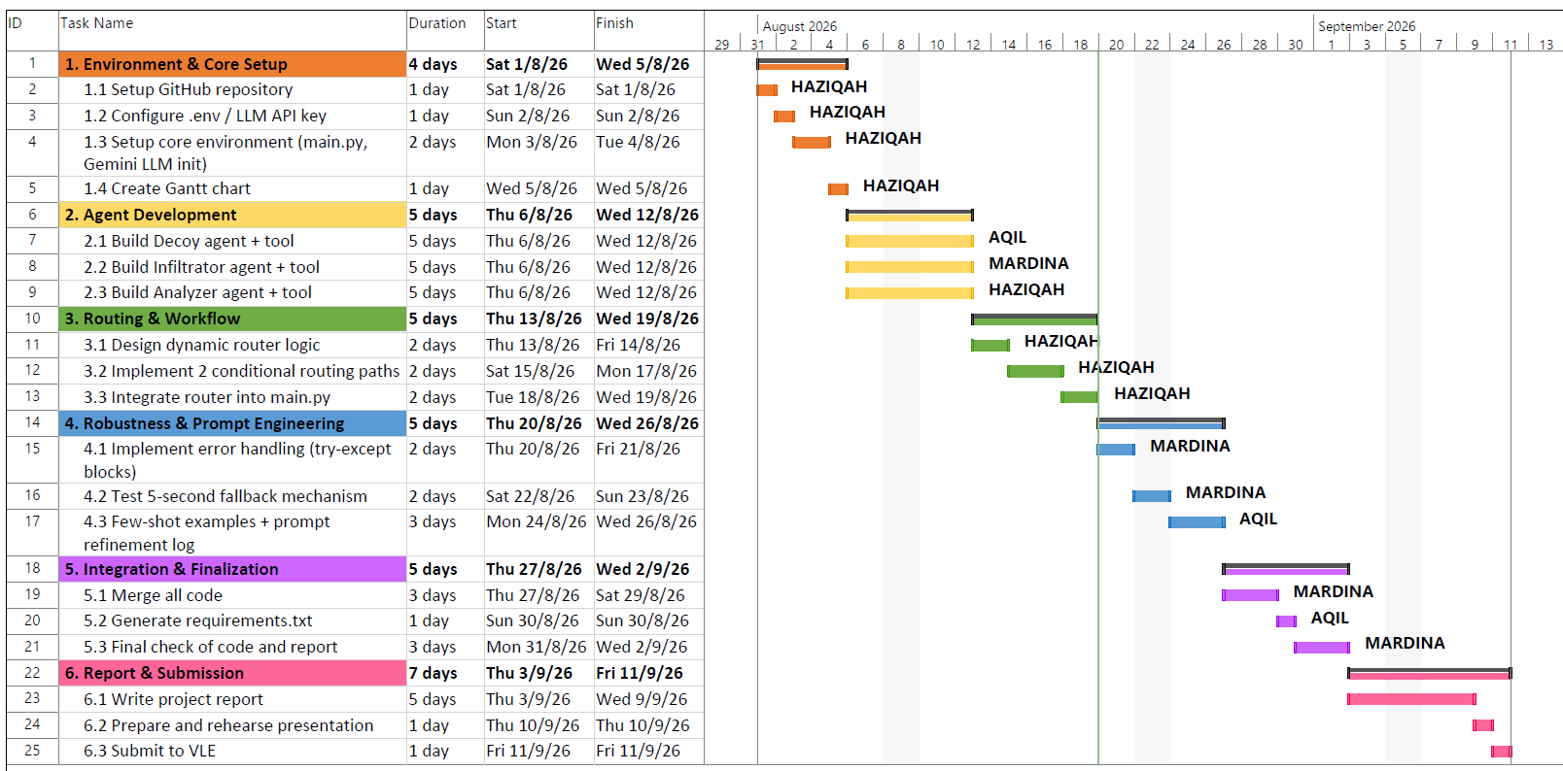

4. Software / Framework / Model
- Orchestration framework: CrewAI
- LLM: Google Gemini (gemini-3.6-flash), accessed via Google AI Studio API
- Approach: LLM API (cloud-based), not a locally-hosted model
- Environment management: python-dotenv (.env) for API key handling

5. Router / Roles Design
- Router type: Dynamic (LLM-driven semantic routing)

The router sends the input to Gemini with a strict prompt asking it to classify threat severity (LOW / MEDIUM / HIGH / CRITICAL). The classification is then mapped into one of two conditional workflow paths. If the LLM call fails, the system falls back to a static keyword scan so routing never crashes.

Agent | Role | Function
Agent 1 | Decoy | Creates distraction and fake traffic to cover the Infiltrator's activity
Agent 2 | Infiltrator | Stealthily extracts the suspicious code fragment from the compromised node
Agent 3 | Analyzer | Statically analyzes the extracted fragment for vulnerabilities and kill-switches, outputs structured JSON verdict

Conditional Routing Paths
Path | Sequence
Low / Medium | Router → Infiltrator → Analyzer → Final response
High / Critical | Router → Decoy → Infiltrator → Analyzer → Final response

6. One prompt for design (Analyzer Agent)

“I’m working on a cyber-defense project using CrewAI, where we have different agents and one of them is called “The Analyzer.” Please help me write the Python code for this agent, its custom tool, and the task.

Please follow these requirements:

1. Analyzer Agent
Create an agent called `analyzer_agent`.This agent should be an expert in analyzing code, finding vulnerabilities, and breaking down suspicious code.It should work like an isolated/air-gapped security analyzer and should have its own role and personality that is different from the other agents. Set `max_execution_time=60`. Set `max_retry_limit=3`.

2. Custom Tool
Create a custom tool called `isolated_code_analyzer_tool` using the `@tool` decorator. It should take a code fragment as a string input. The tool should check the code for possible vulnerabilities, kill-switches, or suspicious parts. Please use `try-except` so that the tool can handle errors safely instead of crashing.

3. Docstrings- make sure the tool's docstring follows PEP 257 properly.”

